**PREDICTING PERSONAL LOAN APPROVAL USING MACHINE LEARNING**

***INTRODUCTION***

* ***OVERVIEW:***
* LOANS are the major requirements of the modern world. By this only, Bank get major part of the total profit.
* It is beneficial for students to manage their education and living expenses, and for people to buy any kind of luxury like houses, cars etc.
* A customer first request for a loan and after the Finance Company validates the customer eligibility for the loan and of approve.
* Details like Marital status, gender, education, and number of dependents, Income, Loan amount, credit history and others are given in the form to fill up by the applicants.
* The target variable here is Applicants “Loan Status” and the other variable are predictors.

***PURPOSE:***

* When you fill out a loan applications, you may come across a section that asks you to specify the purpose of the loan.
* Some lenders do this to give you the right product. They may also use your loan objective to assess risk specify loan terms.
* There are several reasons may might considered out of personal loan.

***PROBLEM DEFINITION & DESIGN THINKING***

**EMPATHY:**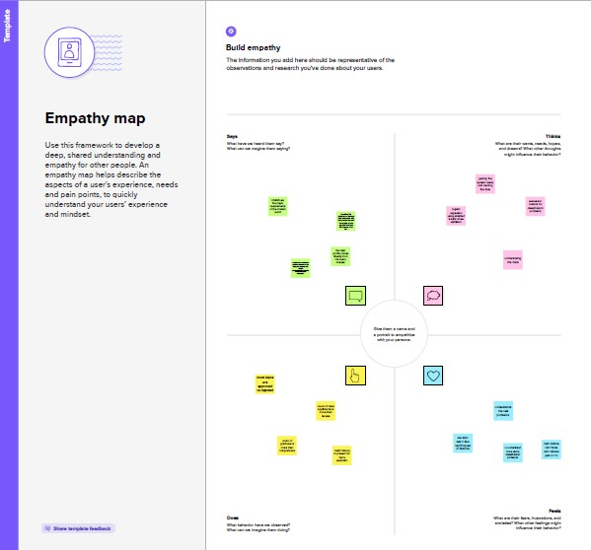

IDEATION & BRAINSTORMING MAP

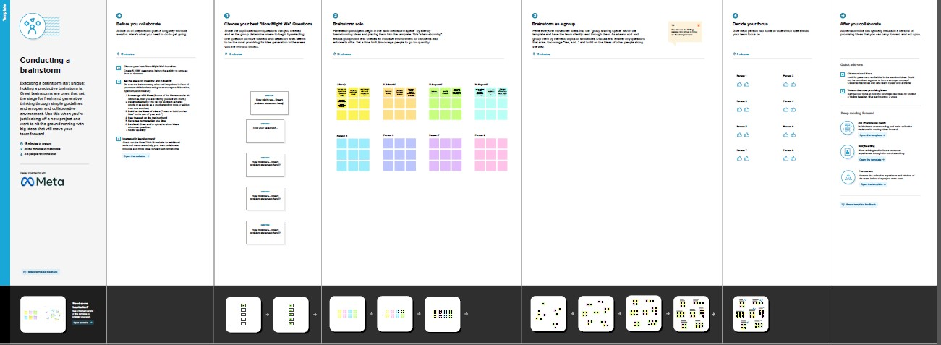

***RESULT***

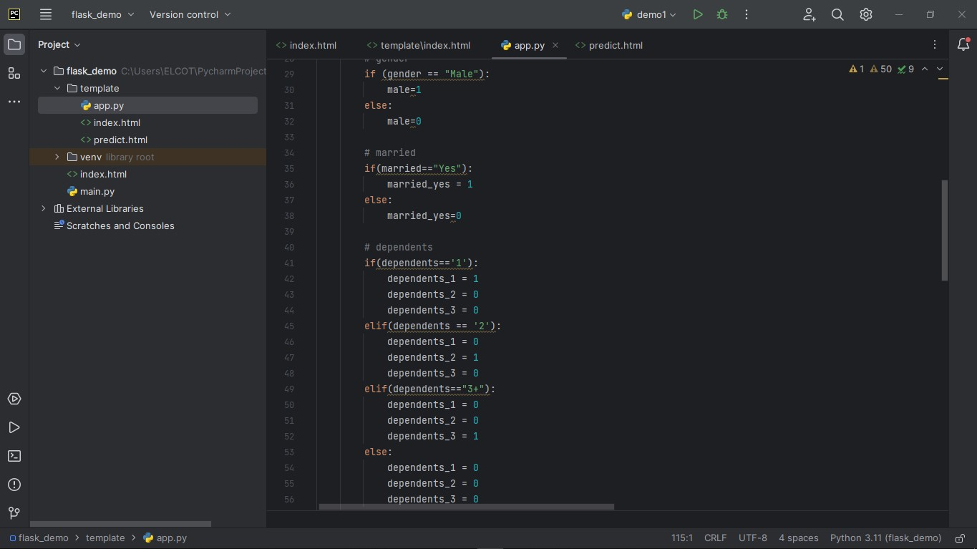

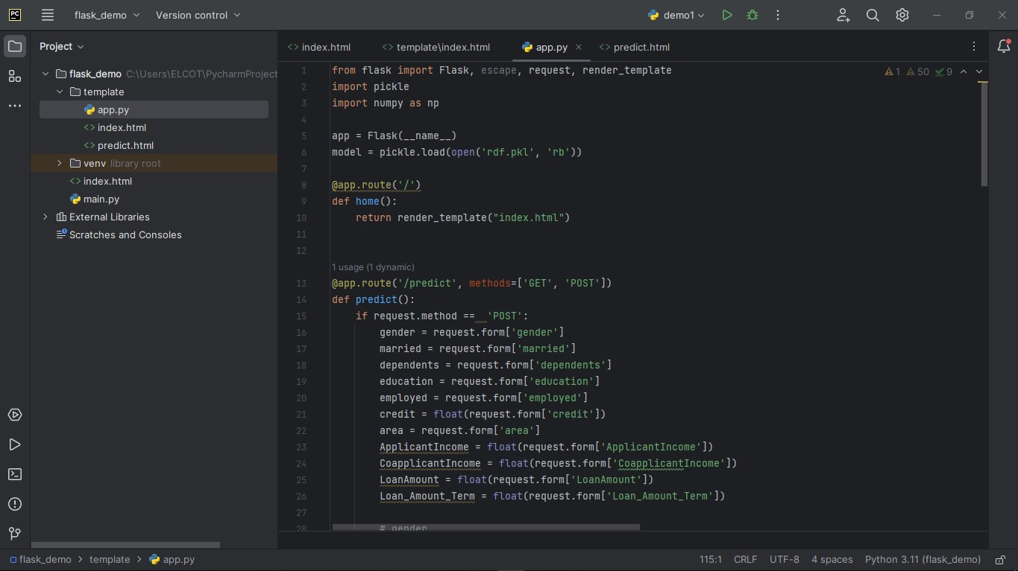

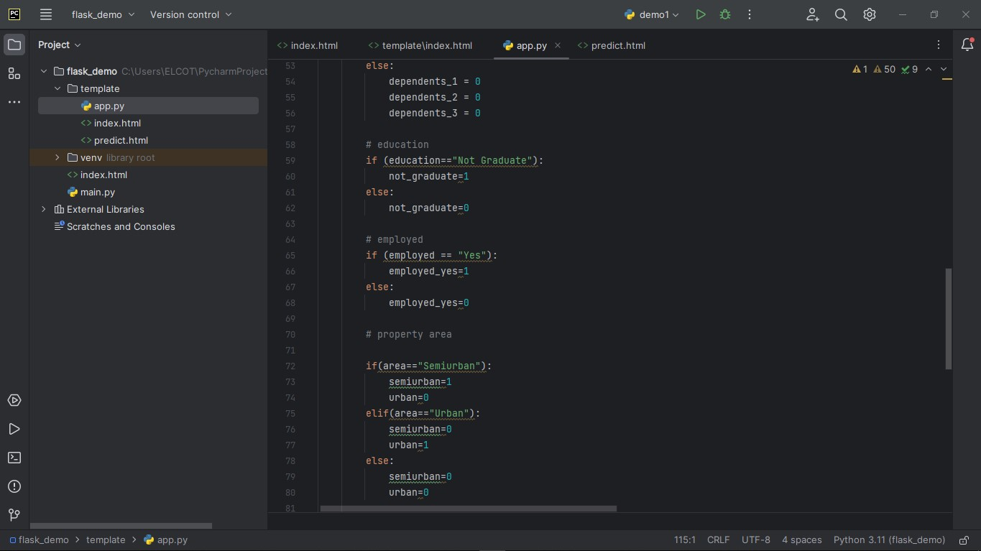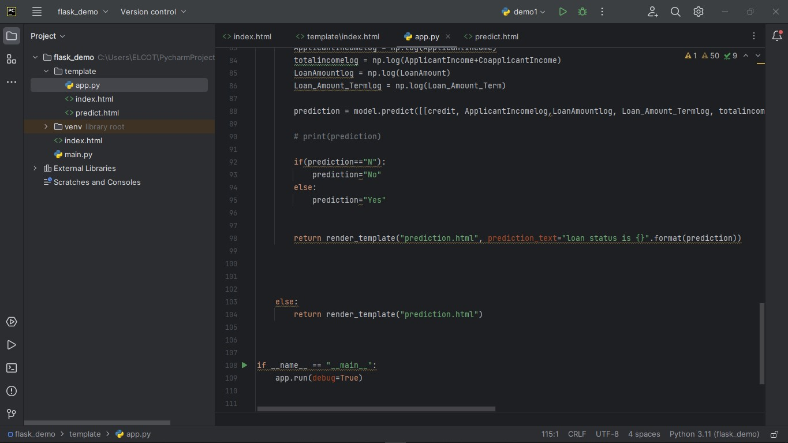

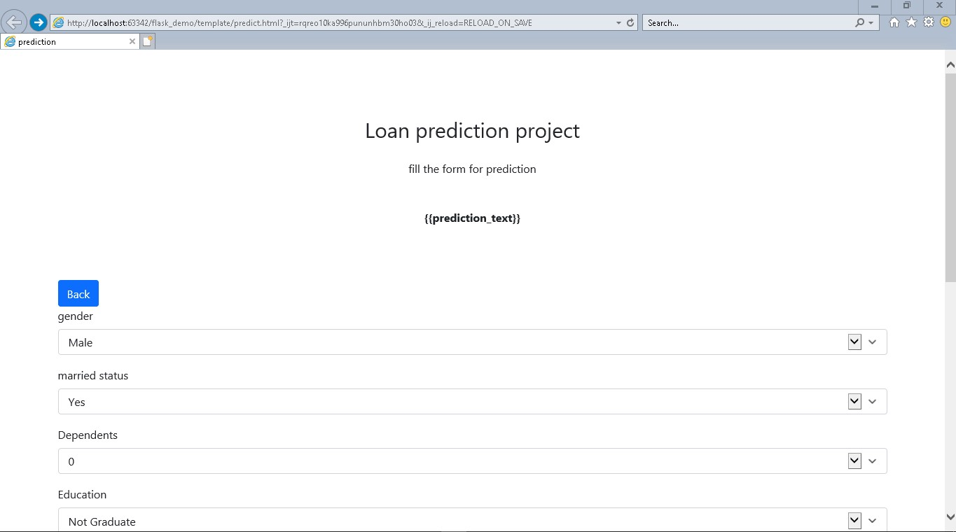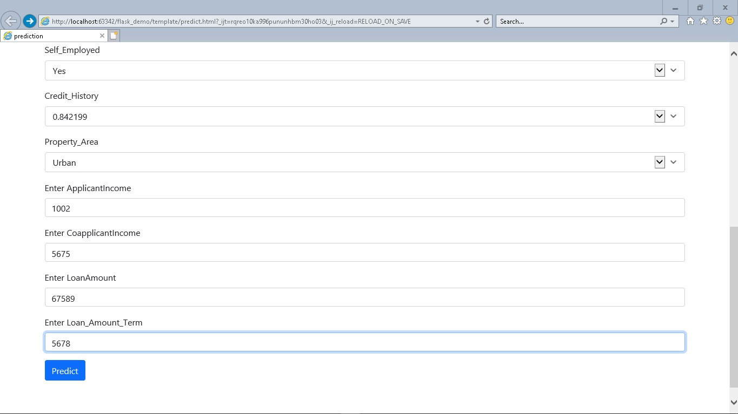

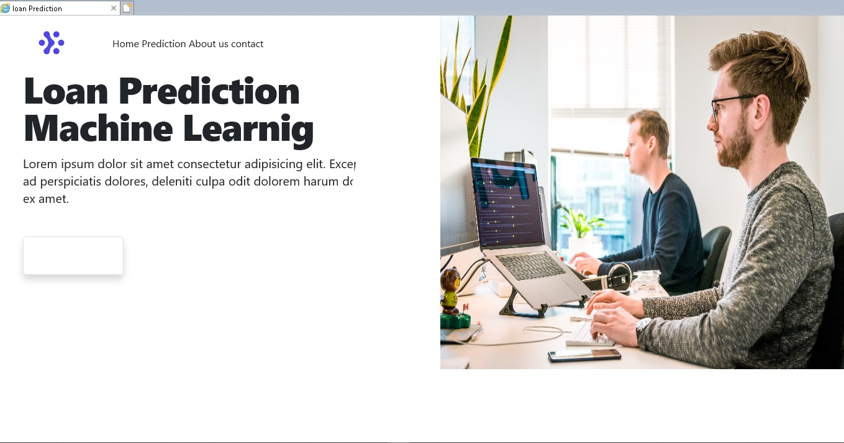

***ADVANTAGE S***

* Ability to pay over time
* Ability to consolidate debt
* Quick decision
* Can be used for almost anything

***DISADVANTAGES***

* Potential fees
* Short-term credit damage (like any loan)
* Collateral sometimes required
* Ability to rack up unnecessary debt

***APPLICATION***

* Instant personal loan
* Money view
* Instant personal loan
* Paysense
* Smart coin-Personal loan app

***CONCLUSION***

* Today, Personal Loan is easily available as several lenders are offering instant personal loan approval.
* There are high chances of misunderstanding and misusing the easy availability which can lead to heavy debt.
* As a responsible person, you should apply for a personal loan only when required.

***FUTURE SCOPE***

* There are several types of loans categorized based on various factors
* you can choose the type of loan you wish to take based on your requirement and eligibility
* A repayment tenure and interest rate will be associated with every loan

***APPENDIX***

**Source code:**

